2023 Wreath Sponsorship Order Form

Sponsored wreaths are placed on grave markers at state and national veterans’ cemeteries, as well as at local and community cemeteries each December for National Wreaths Across America Day.

Your donation will ensure the placement of a veteran’s wreath for one or more veterans laid to rest at the participating location of your choice.

Please make checks payable to:
Wreaths Across America
Mail to:
CAHS PATRIOTS, INC.
304 Stadium Road, Connellsville, PA 15425
Deadline is November 5, 2023
Thank you for your sponsorship and joining us in our mission to Remember, Honor and Teach!

To split your donation between multiple groups and/or locations, please list the IDs and dollar amounts for each.
CHECK # |  | CHECK DATE |  | SPONSOR NAME FOR DISPLAY  If different than name on check.
GROUP ID(s) | PA0051P |  |  | EMAIL ADDRESS
LOCATION ID(s) | PANCAB |  |  | PHONE #
DOLLAR AMOUNTS(s) |  |  |  | MAILING ADDRESS

SPECIAL REQUESTS
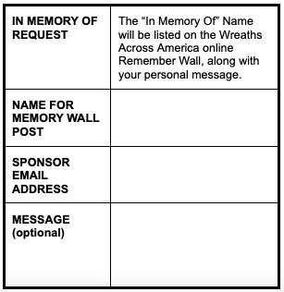
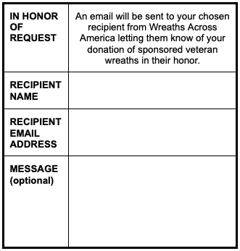
Please note in memory/honor of requests do not place a wreath on a specific loved one’s grave.

Thank you for supporting our mission to REMEMBER, HONOR, and TEACH!

